Lab 11 -- Utilizing prompt engineering to enhance model responses
Estimated Duration: 20 minutes
Lab Type: Instructor Led
Introduction
GPT-3, GPT-3.5, and GPT-4 models from OpenAI are prompt-based. With prompt-based models, the user interacts with the model by entering a text prompt, to which the model responds with a text completion. This completion is the model's continuation of the input text. While these models are extremely powerful, their behavior is also very sensitive to the prompt. This makes prompt construction an important skill to develop.
With the Azure OpenAI Service, developers can create chatbots, language models, and other applications that excel at understanding natural human language. The Azure OpenAI provides access to pre-trained AI models, as well as a suite of APIs and tools for customizing and fine-tuning these models to meet the specific requirements of your application.
When working with the Azure OpenAI Service, how developers shape their prompt greatly impacts how the generative AI model will respond. Azure OpenAI models are able to tailor and format content, if requested in a clear and concise way.
Imagine you are trying to send out information for a new wildlife rescue, and want to get assistance from a generative AI model. In this lab, you'll learn how to deploy a model in Azure OpenAI and use it in your own application to summarize text.
Objectives
- To deploy gpt-35 turbo model and examine how prompt engineering improves the model response in the Azure AI Studio Chat playground.
- To setup, configure, and run your application in Cloud Shell to know how different prompts for similar content help shape the AI model's response to better satisfy your requirements.
Prerequisites
- • Before starting this lab, kindly complete the Exercise 0 and 1 of Lab 10 - Provisioning Azure OpenAI resource.

Task 1: Deploy gpt-35-turbo model
To use the Azure OpenAI API, you must first deploy a model to use through the Azure OpenAI Studio. Once deployed, we will reference that model in our app.
- Open your browser and navigate to https://oai.azure.com/
Note: If you are directed to the Azure OpenAI Studio home page, then skip steps from #2 to #4, else continue.
- In the Microsoft Azure window, enter your Sign-in credentials, and click on the Next button.
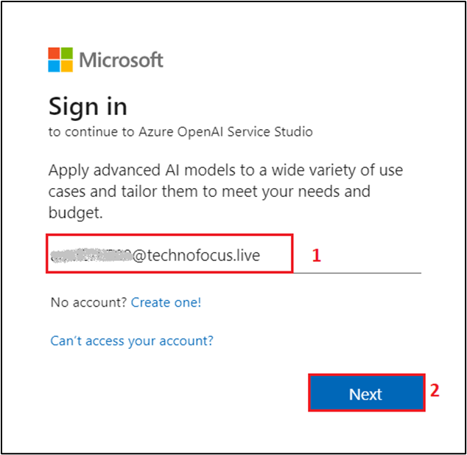
- Then, enter the password and click on the Sign in button.
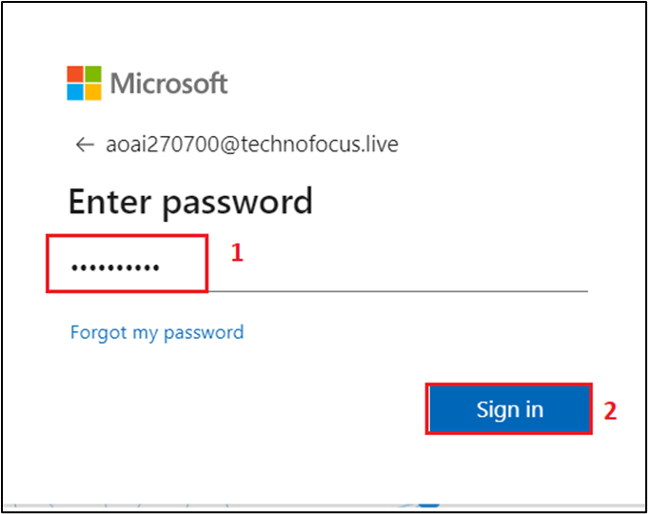
- In Stay signed in? window, click on the Yes button.
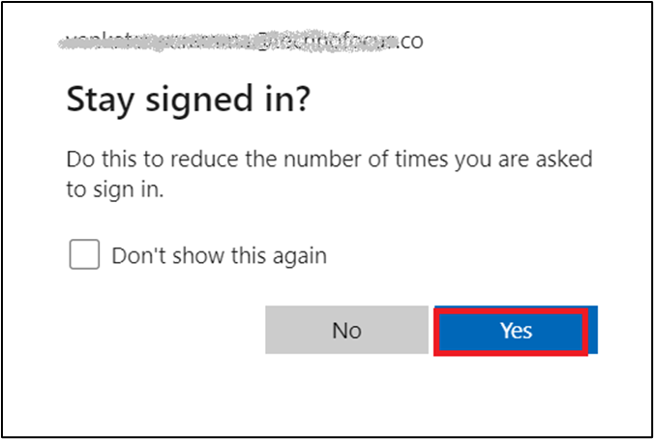
- On the Welcome to Azure OpenAI Studio dialog box(if prompted), under the Subscription field, select your subscription, and in the Resource field, select the Resource name that you’ve created in Lab #10, and then click on the Use resource button.
Note: You might not get the dialog if the resource is automatically selected. Ensure that the correct resources are selected.
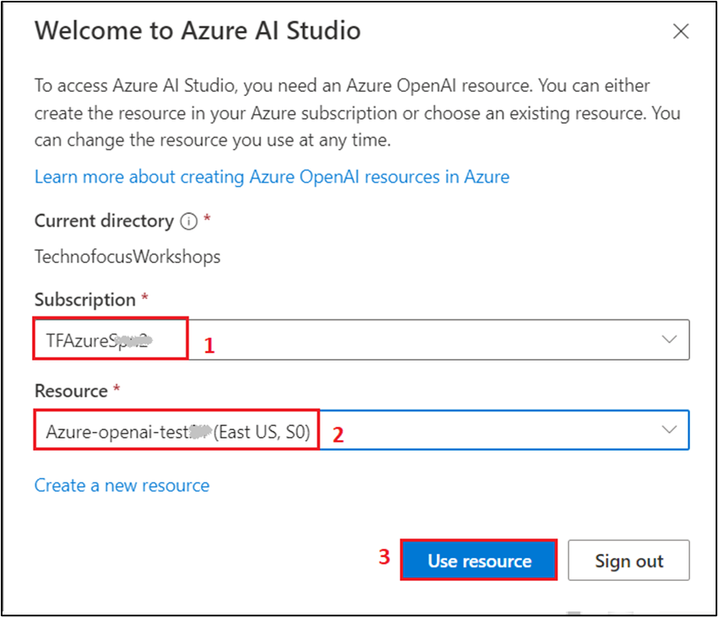
- Wait for the Azure OpenAI studio to launch.
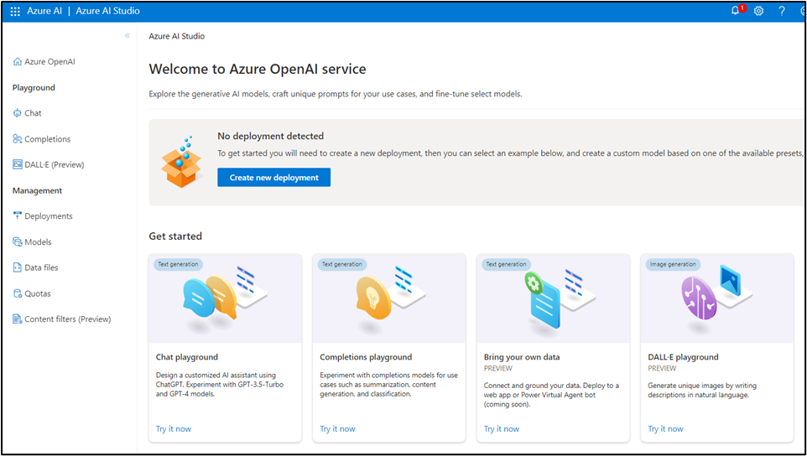
- On the Azure OpenAI Studio homepage, click on Create new deployment button.
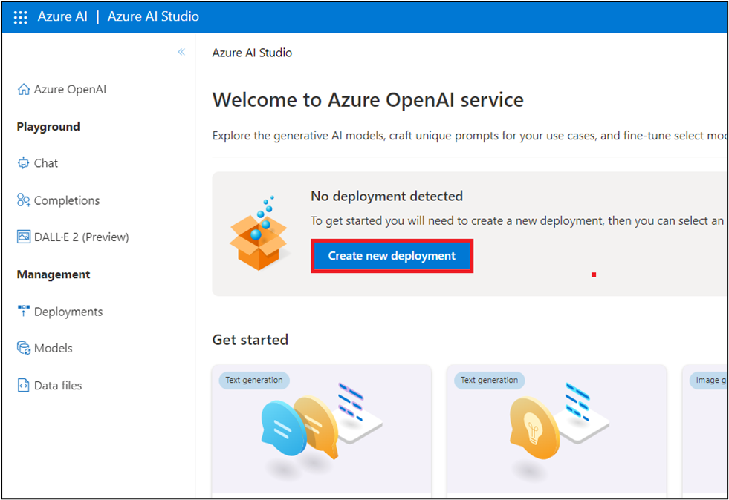
- In the Deployments page, click on +Create new deployment.
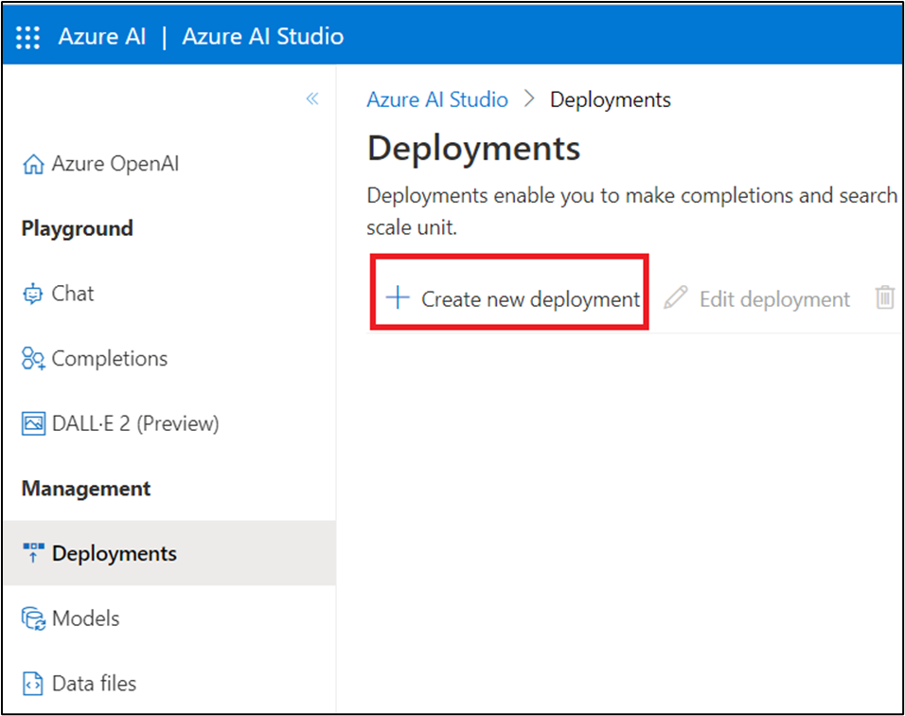
- In the Deploy model dialog box, under the Model name field, click on the V chevron button; navigate and select carefully gpt-35-turbo.
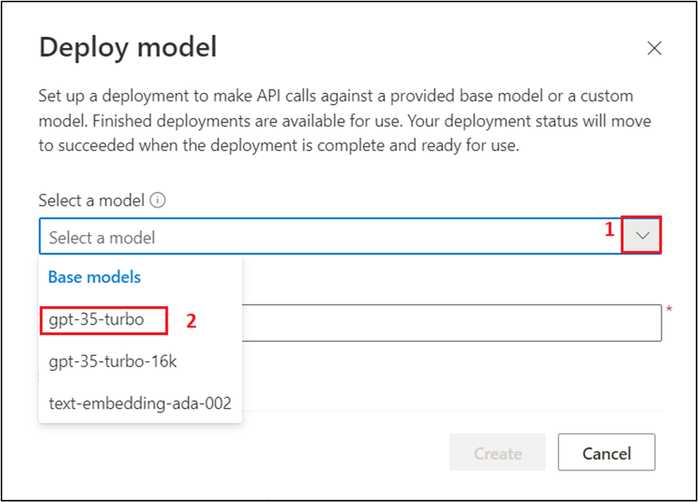
- Select the Model version as Auto-update to default, in the Deployment name field, enter text-turbo, and click on the Create button.
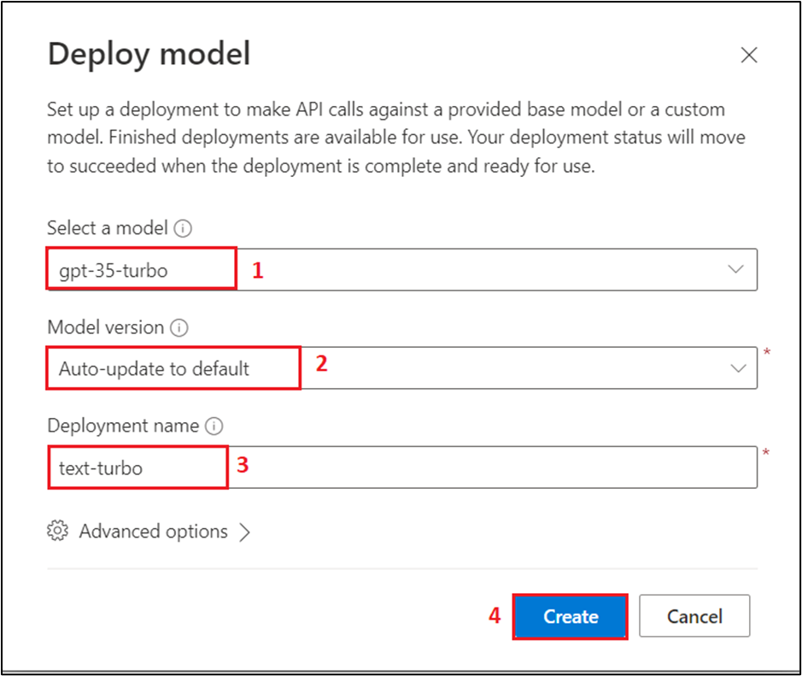
Note: Azure OpenAI includes multiple models, each optimized for a different balance of capabilities and performance. In this exercise, you’ll use the GPT-35-Turbo model, which is a good general model for summarizing and generating natural language and code. For more information about the available models in Azure OpenAI, see Models in the Azure OpenAI documentation.
- You will see a notification – Successfully Created deployment when the deployment is succeeded. (You can also view the notification by clicking on the bell icon beside Azure AI | Azure AI Studio).
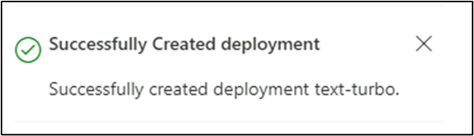

Task 2: Apply prompt engineering in Chat playground
Before using app, examine how prompt engineering improves the model response in the playground. In this first example, we are trying to write a python app of animals with fun names.
- In Azure OpenAI Studio, navigate to the Playground section on the left side and click on Chat.
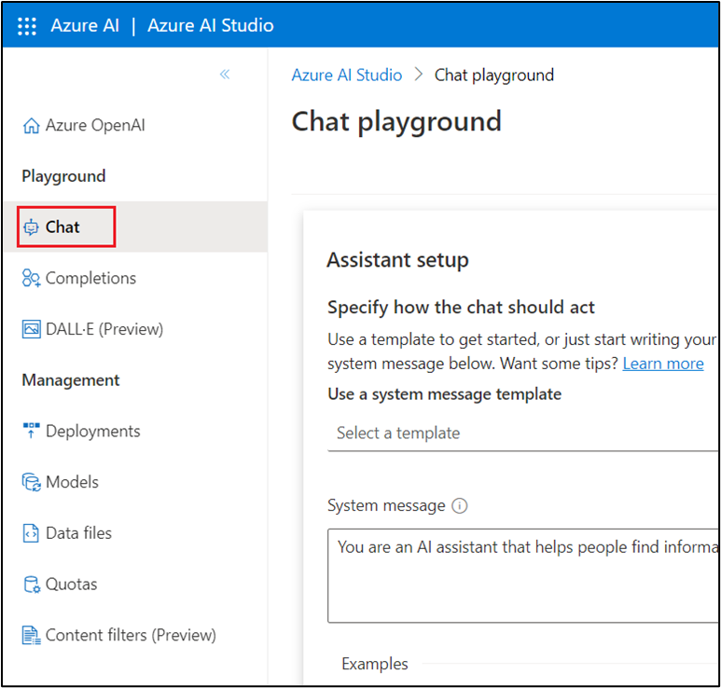
- On the Chat playground page, under Assistant setup section, in the System message textbox, enter You are a helpful AI assistant.
Note: You can use Ctrl+- or Ctrl+minus keyboard shortcut to zoom out and decrease the font size, so that Chat session pane appear on the right side.
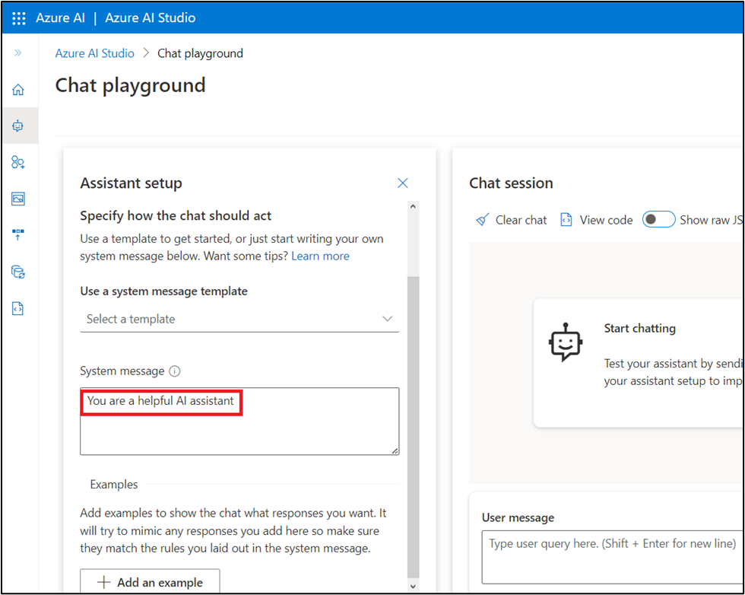
- In the Chat session section, enter the following prompt in the User message text box and click on the Send icon.
python
1. Create a list of animals
2. Create a list of whimsical names for those animals
3. Combine them randomly into a list of 25 animal and name pairs
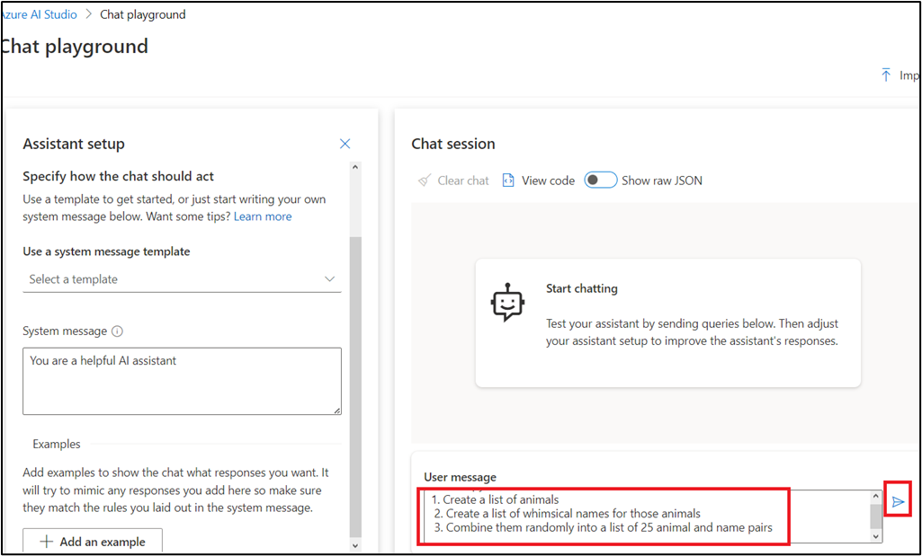
- The model will likely respond with an answer to satisfy the prompt, split into a numbered list. This is a good response, but not what we're looking for.
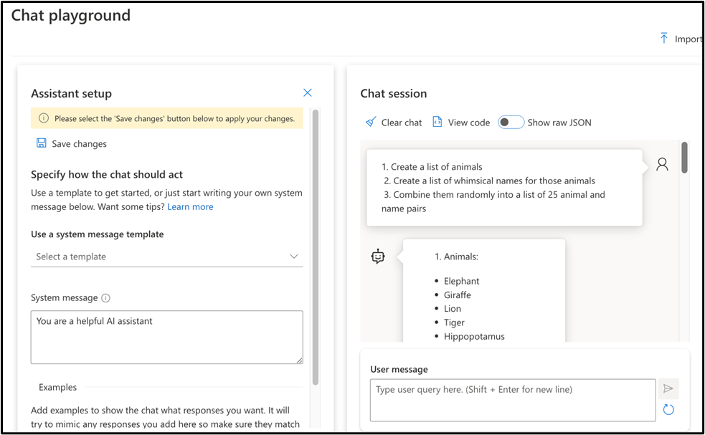
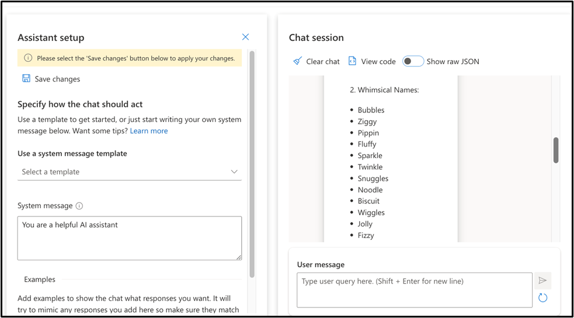
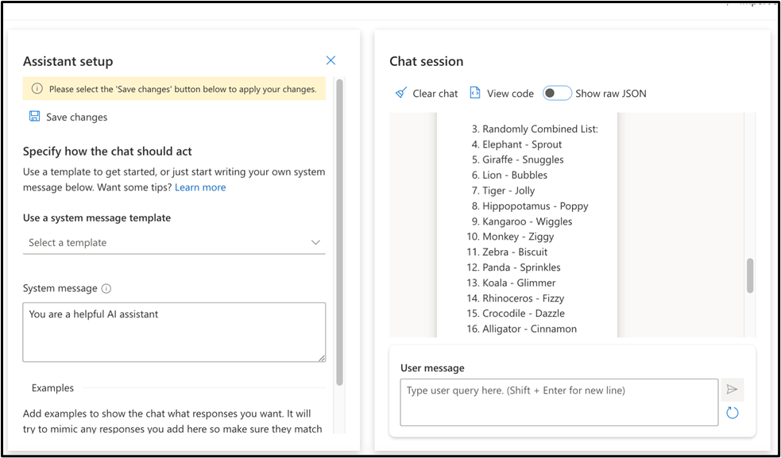
- In the System message text box, replace the previous text with the following text to include instructions You are an AI assistant helping write python code. Complete the app based on provided comments Then, click on Save changes.
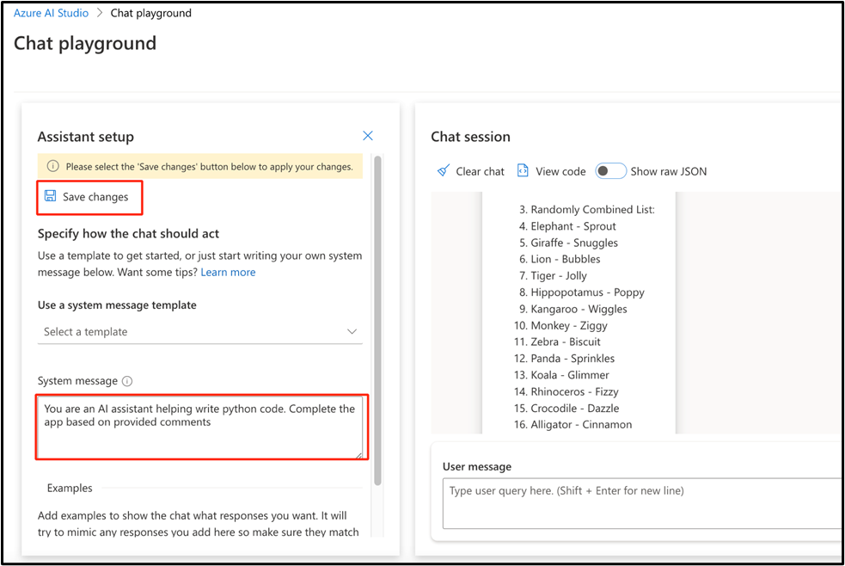
- In the Update system message? dialog box, click on the Continue button.
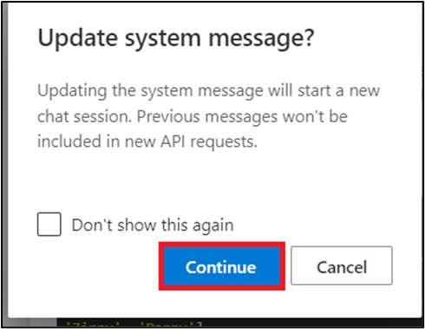
- Format the instructions as python comments. Send the following prompt to the model by pasting them in User message text box and clicking on the Send icon.
python
# 1. Create a list of animals
# 2. Create a list of whimsical names for those animals
# 3. Combine them randomly into a list of 25 animal and name pairs
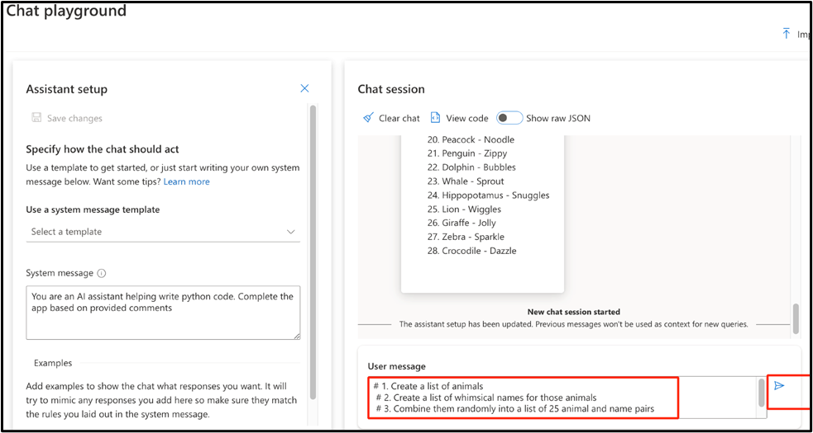
- The model will respond with complete python code that can accomplish the instructions provided through the python comments.
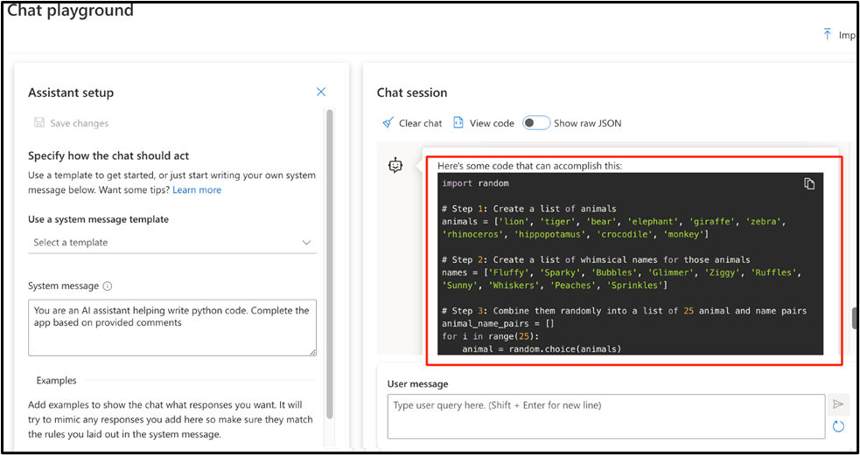
- Next, you'll see the impact of few shots prompting when attempting to classify articles. Go back to the System message text box, select and delete the previous text and enter You are a helpful AI assistant again, and click on Save changes. This will create a new chat session.
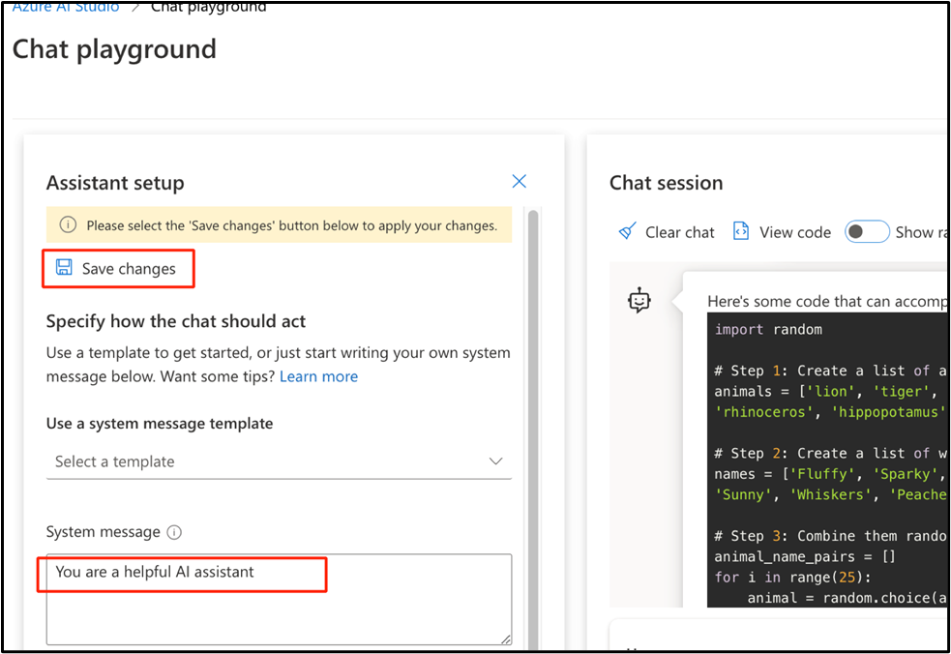
- In the Update system message? dialog box, click on the Continue button.

- In the User message text box, enter the following text and click on the Send icon.
- Severe drought likely in California

- Millions of California residents are bracing for less water and dry lawns as drought threatens to leave a large swath of the region with a growing water shortage.

- In a remarkable indication of drought severity, officials in Southern California have declared a first-of-its-kind action limiting outdoor water use to one day a week for nearly 8 million residents.

Much remains to be determined about how daily life will change as people adjust to a drier normal. But officials are warning the situation is dire and could lead to even more severe limits later in the year.
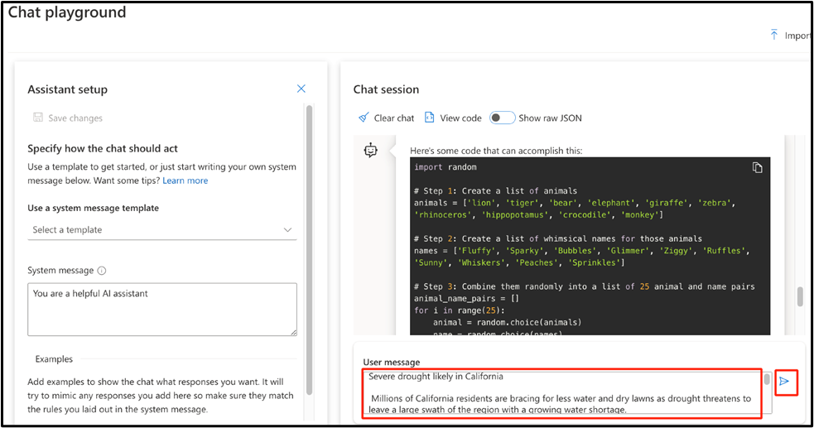
- The response will likely be some information about drought in California. While not a bad response, it's not the classification we're looking for.
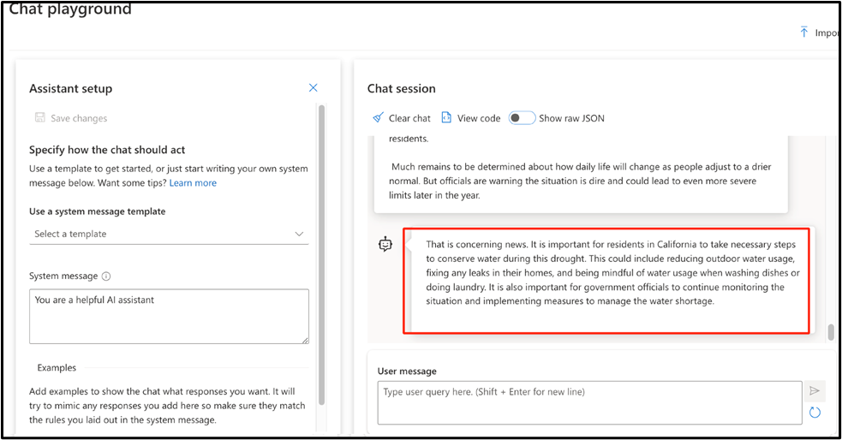
Note: You may receive a similar or different response from the model.
- In the Assistant setup section, below the System message text box, click on +Add an example button. Then, add the following text in User and Assistant text boxes as shown in the below image.
User:
New York Baseballers Wins Big Against Chicago

New York Baseballers mounted a big 5-0 shutout against the Chicago
Cyclones last night, solidifying their win with a 3 run homerun late
in the bottom of the 7th inning.

Pitcher Mario Rogers threw 96 pitches with only two hits for New York,
marking his best performance this year.

The Chicago Cyclones' two hits came in the 2nd and the 5th innings,
but were unable to get the runner home to score.
Assistant:
Sports
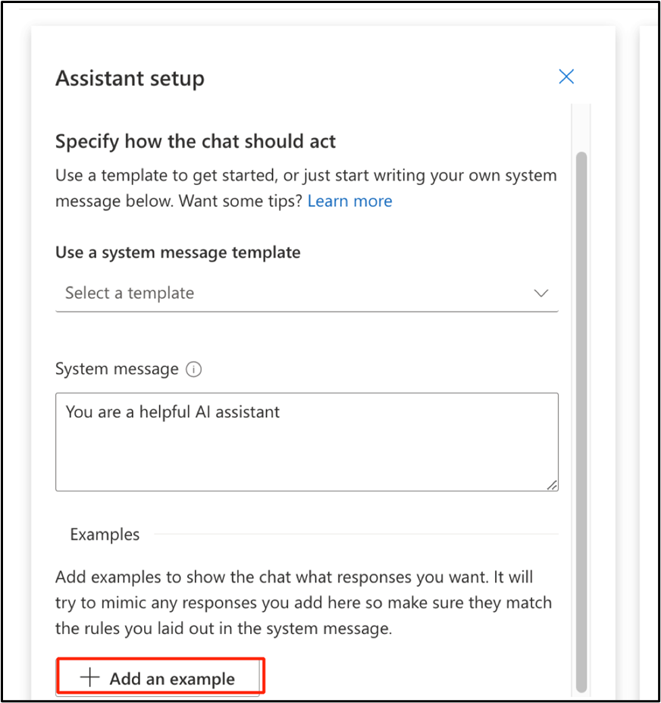
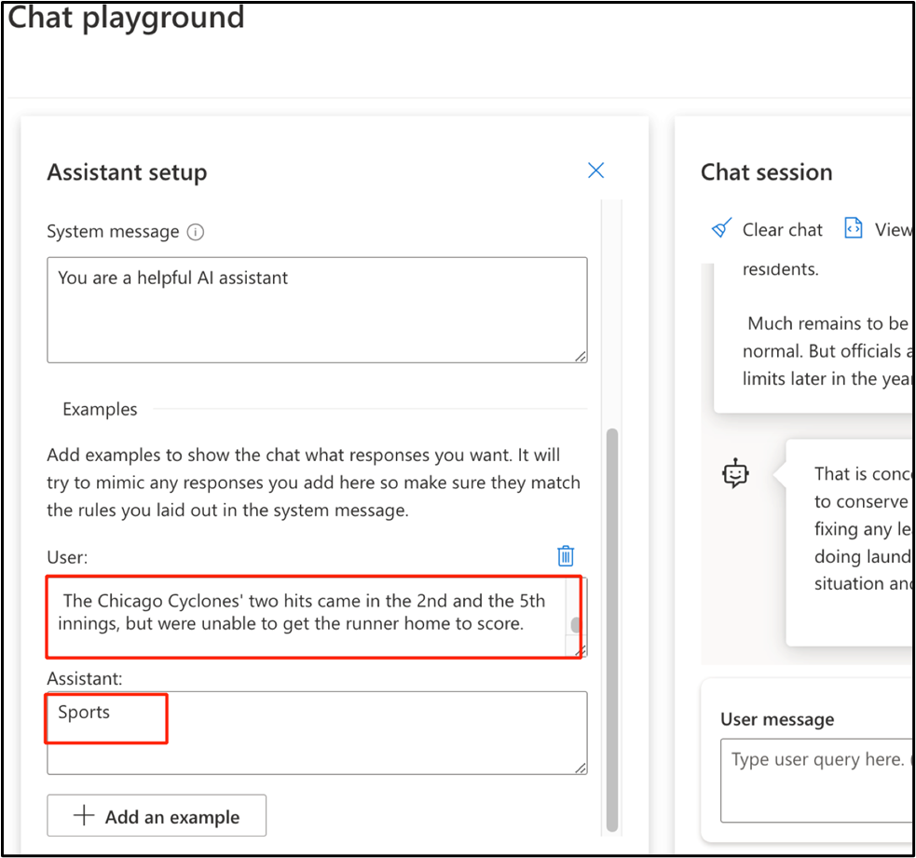
- Click again on +Add an example button to add another example. Then, add the following text in User and Assistant text boxes as shown in the below image:
User:
Joyous moments at the Oscars

The Oscars this past week where quite something!

Though a certain scandal might have stolen the show, this year's
Academy Awards were full of moments that filled us with joy and even
moved us to tears.

These actors and actresses delivered some truly emotional
performances, along with some great laughs, to get us through the
winter.

From Robin Kline's history-making win to a full performance by none
other than Casey Jensen herself, don't miss tomorrows rerun of all
the festivities.
Assistant:
Entertainment
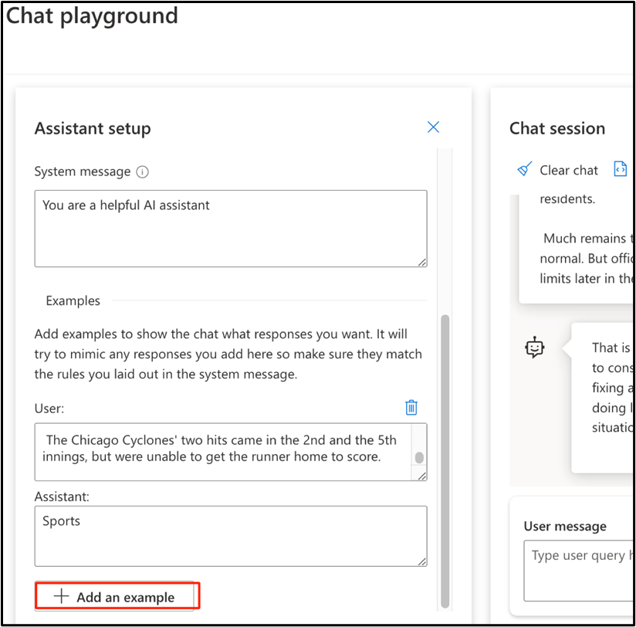
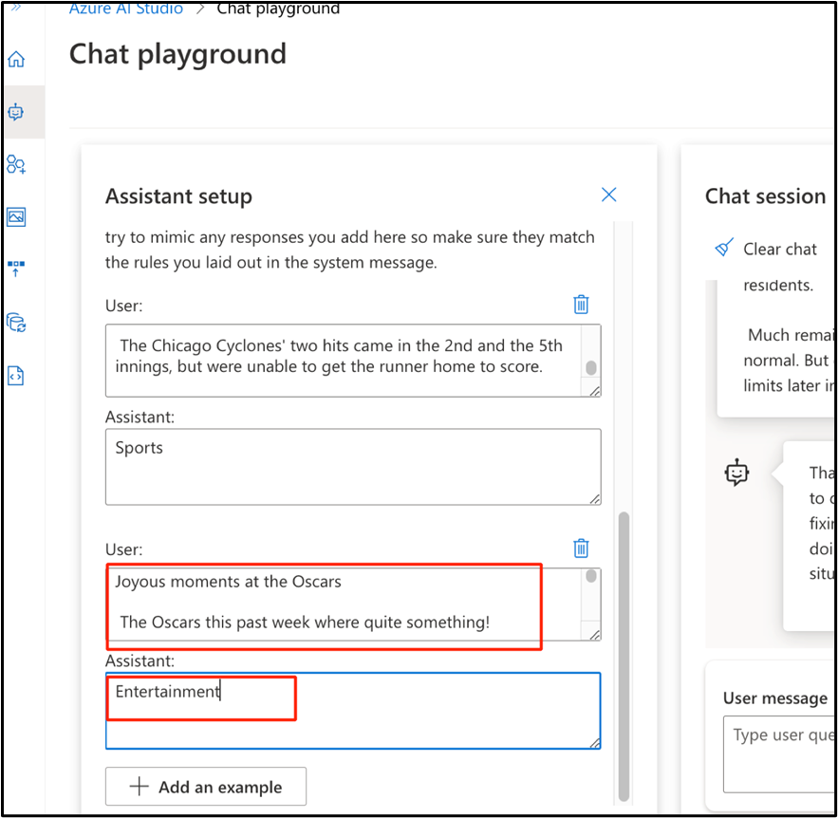
- Then, click on Save changes to save the changes that you have made to the assistant setup.
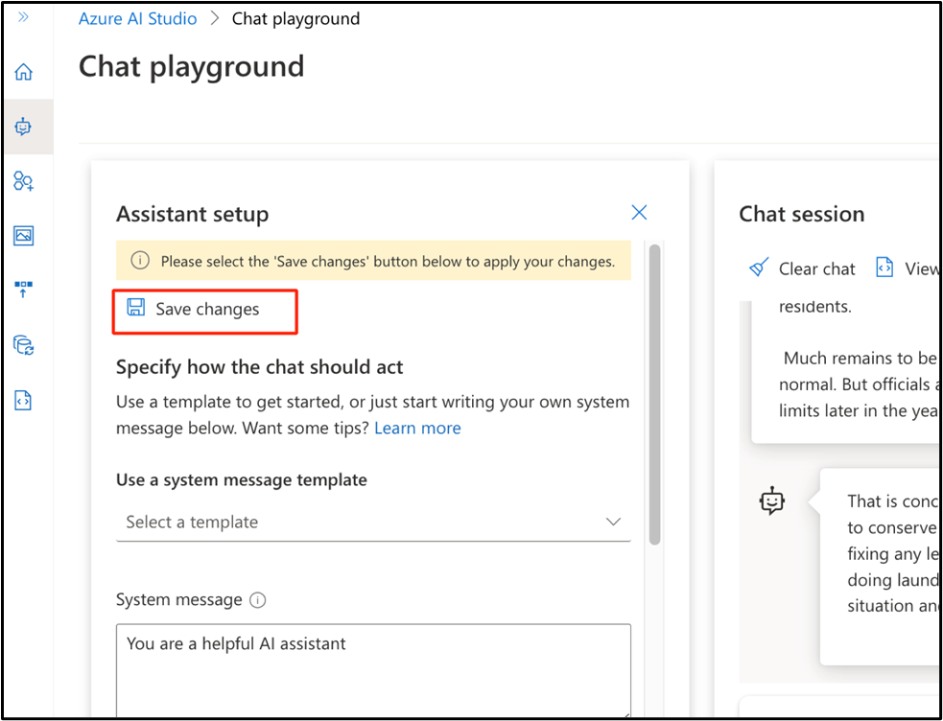
- In the Update system message? dialog box, click on the Continue button.

- Send the same prompt about California drought. In the User message text box, enter the following text and click on the Send icon.
- Severe drought likely in California

- Millions of California residents are bracing for less water and dry lawns as drought threatens to leave a large swath of the region with a growing water shortage.

- In a remarkable indication of drought severity, officials in Southern California have declared a first-of-its-kind action limiting outdoor water use to one day a week for nearly 8 million residents.

Much remains to be determined about how daily life will change as people adjust to a drier normal. But officials are warning the situation is dire and could lead to even more severe limits later in the year.
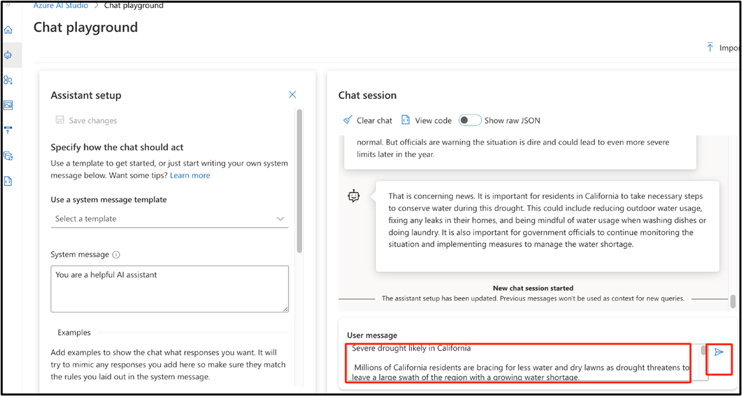
- This time the model will respond with an appropriate classification, even without instructions.
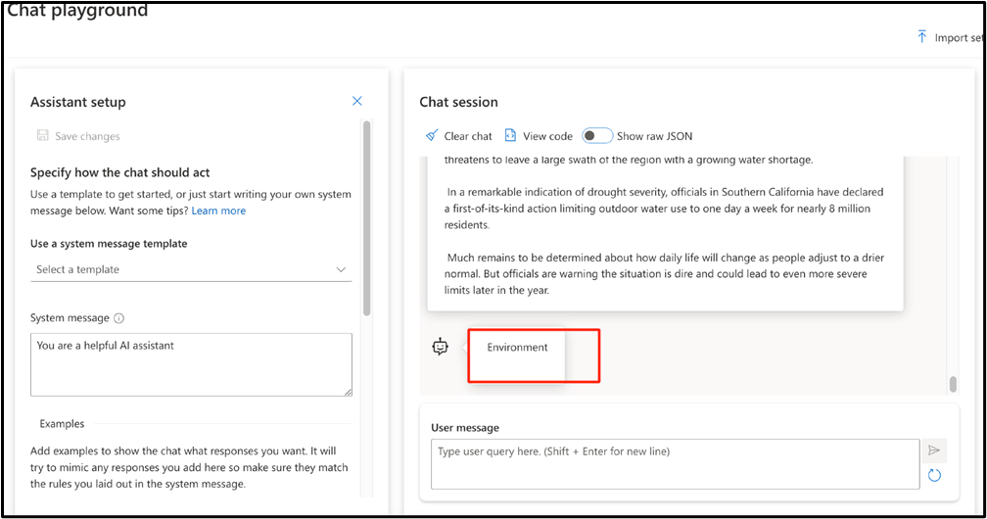

Task 3: Set up an application in Cloud Shell
To integrate with an Azure OpenAI model, use a short command-line application that runs in Cloud Shell on Azure.
- Open a new browser and enter the following URL in the address bar: https://portal.azure.com/ to open the Azure Portal.
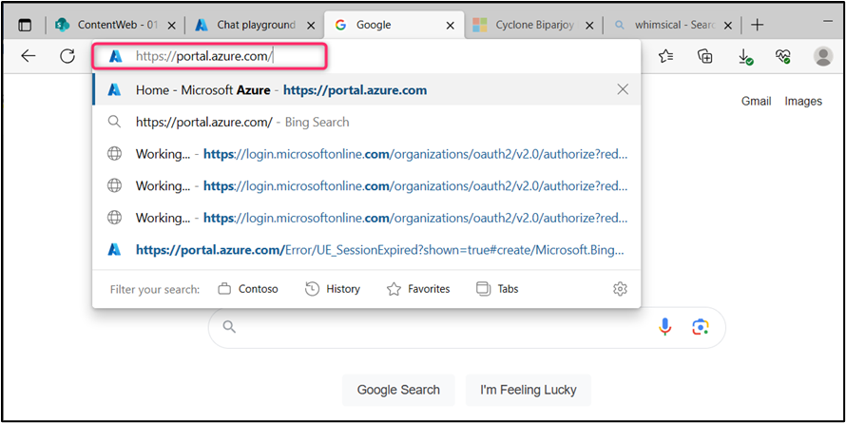
- In the Azure portal, click on the >_ (Cloud Shell) button at the top of the page to the right of the search box. A Cloud Shell pane will open at the bottom of the portal. The first time you open the Cloud Shell, you may be prompted to choose the type of shell you want to use (Bash or PowerShell). Select Bash. If you don't see this option, then skip this step.
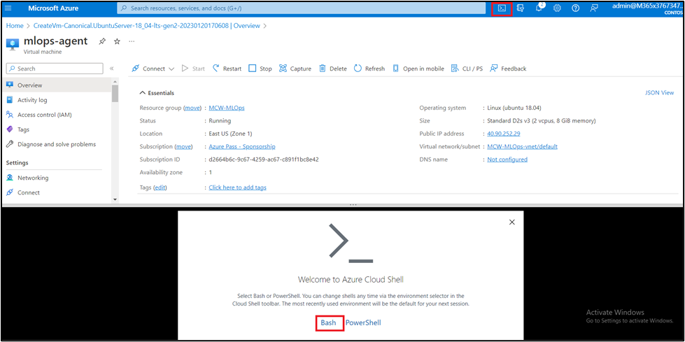
- In You have no storage mounted dialog box, click on Create Sorage.
- Ensure the type of shell indicated on the top left of the Cloud Shell pane is switched to Bash. If it's PowerShell, switch to Bash by using the drop-down menu.
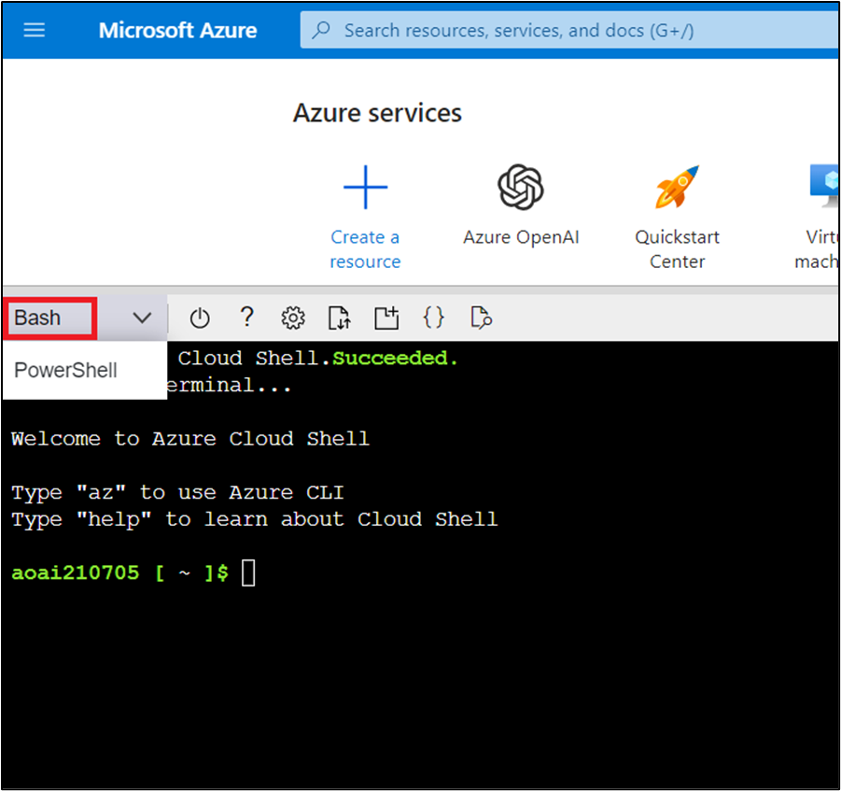
- Once the terminal starts, enter the following command to download the sample application.
git clone https://github.com/getazureready/mslearn-openai
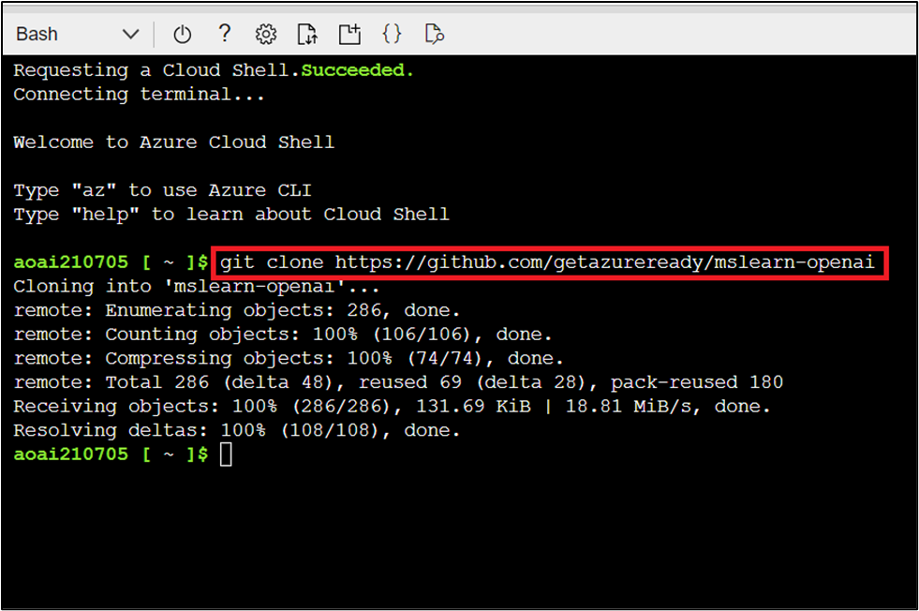
- The files will be downloaded. Navigate to the lab files for this exercise using the following command.
cd mslearn-openai/Labfiles/03-prompt-engineering
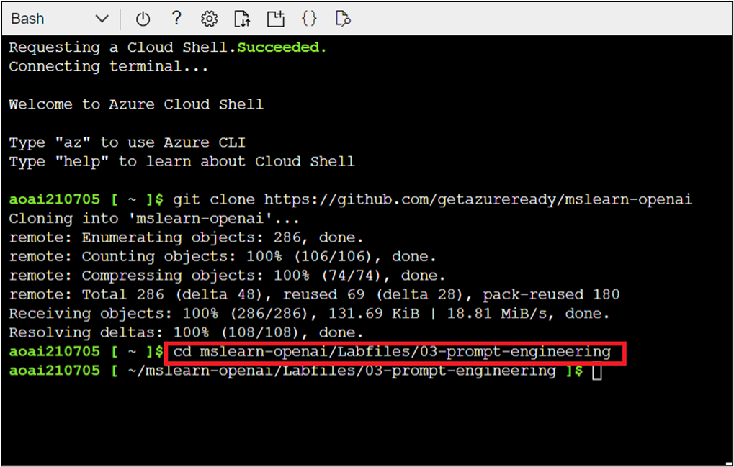
- Applications for both C# and Python have been provided as well as the text files that provide the prompts. Both apps feature the same functionality.
- Open the built-in code editor, and you can observe the prompt files that you will be using in prompts. Use the following command to open the lab files in the code editor.
code .
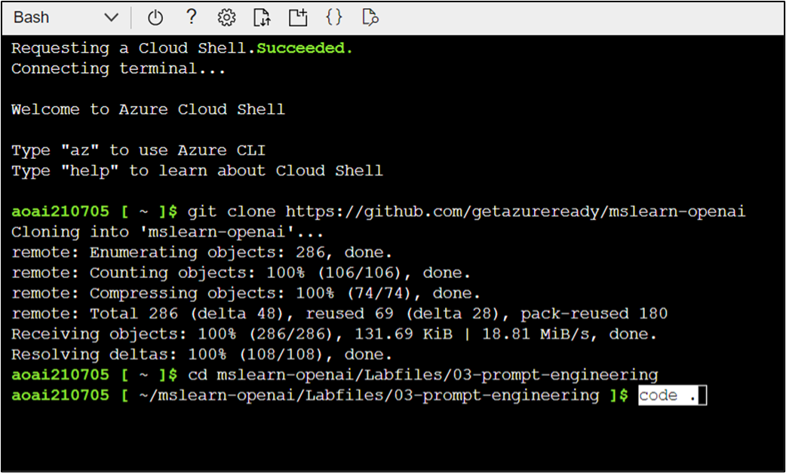

Task 4: Configure your application
In this task, you’ll be configuring your application.
- In the code editor, expand the Python folder, click on .env file. In the .env file, enter the below details.
  - AZURE_OAI_ENDPOINT=Your resource Endpoint
  - AZURE_OAI_KEY=Your OpenAI Service Key
  - AZURE_OAI_MODEL=text-turbo
Note: In case, you did not have Keys and Endpoint values, then you can obtain it again by navigating to Azure portal Home>Resource groups> Your Resource Group> Azure OpenAI Service> Keys and Endpoint. Copy and paste the Keys and Endpoint values to a notepad
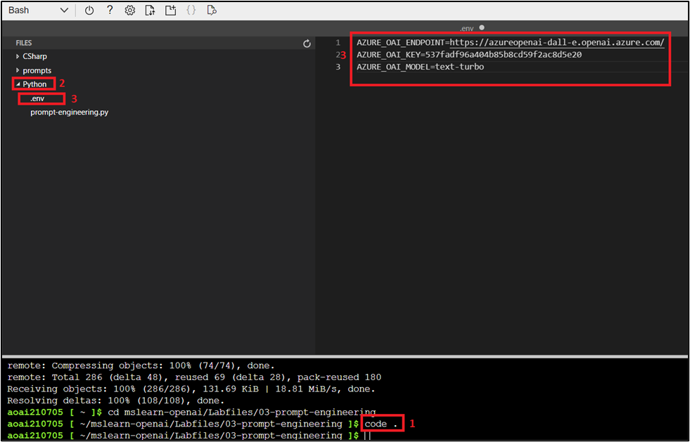
- Press Ctrl+S to save the changes. Then, press Ctrl+Q to quit the code editor.
- Now, install the necessary packages of Python using the following commands.
cd Python
pip install python-dotenv
pip install openai
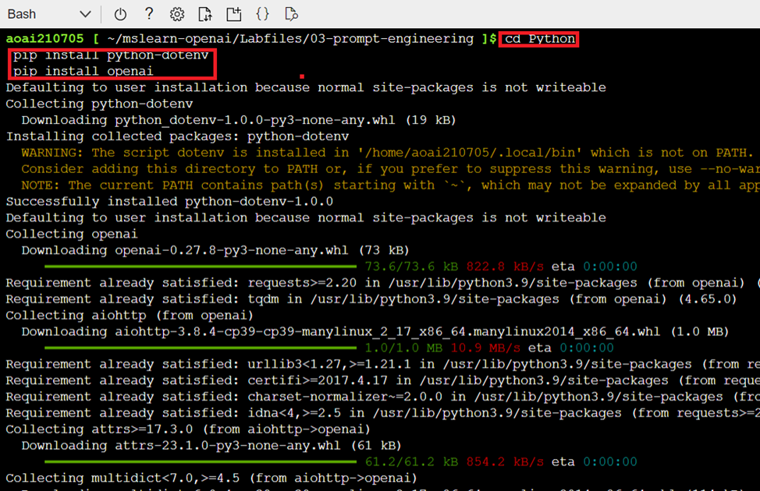
- Open the lab files in the code editor, then click on prompt-engineering.py file and add the necessary libraries. Use the following command to open the lab files in the code editor.
code .
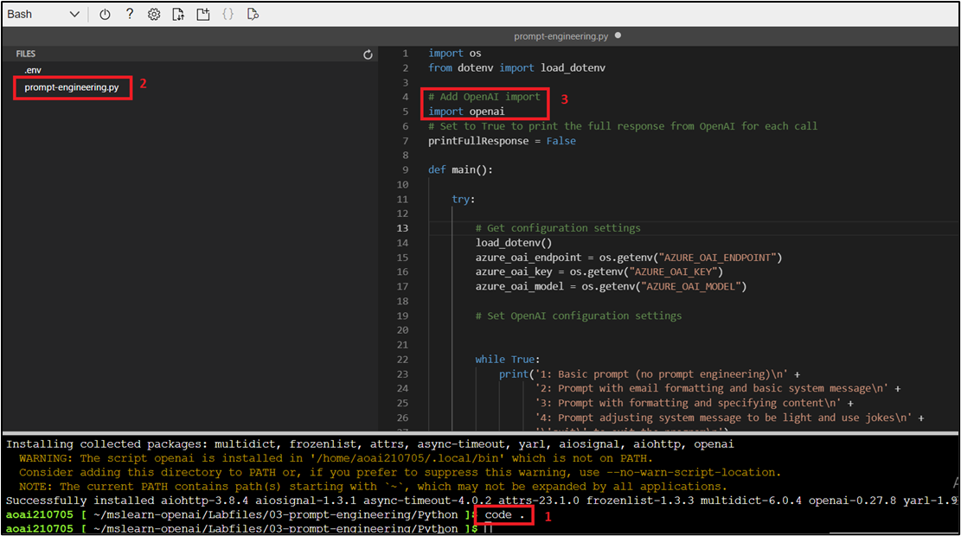
- In the application code, navigate to # Add OpenAI import and add the following code. Press Ctrl+S to save the changes.
- # Add OpenAI import
import openai
- Then, navigate to # Set OpenAI configuration settings and add the following code to configure the client.
- # Set OpenAI configuration settings
- openai.api_type = "azure"
- openai.api_base = azure_oai_endpoint
- openai.api_version = "2023-03-15-preview"
openai.api_key = azure_oai_key
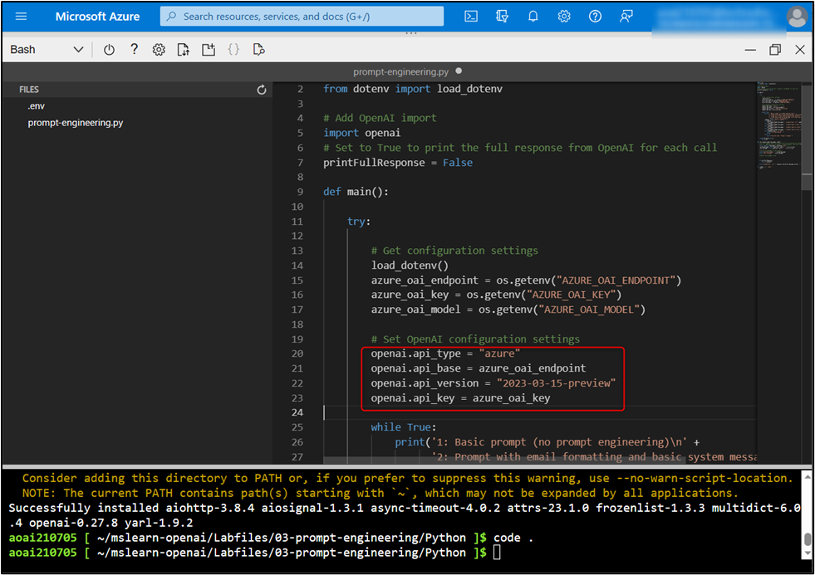
- In the function that calls the Azure OpenAI model, add the code to format and send the request to the model.
- # Build the messages array
- messages = [
- {"role": "system", "content": system_message},
- {"role": "user", "content": user_message},
- ]

- # Call the Azure OpenAI model
- response = openai.ChatCompletion.create(
- engine=model,
- messages=messages,
- temperature=0.7,
- max_tokens=800
)
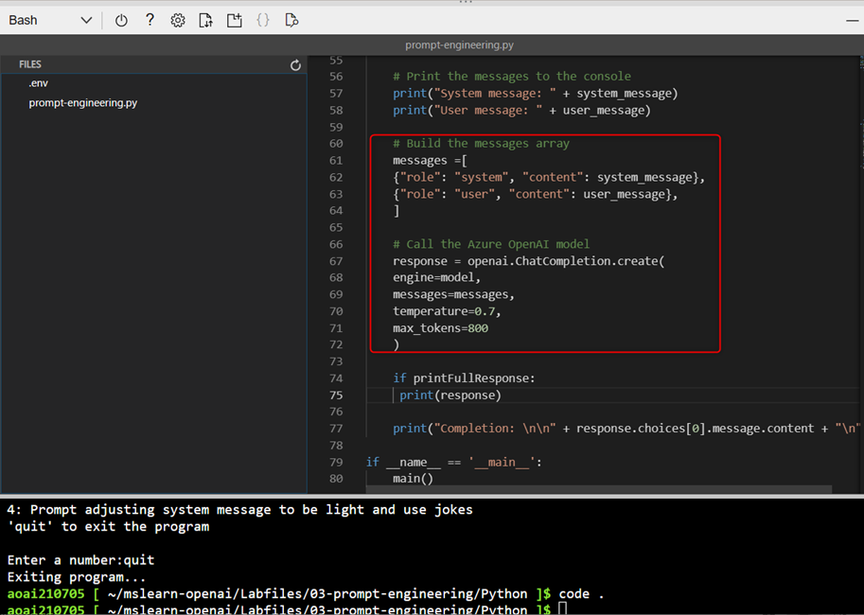
- Press Ctrl+S to save the changes and then press Ctrl+Q to quit the code editor.

Task 5: Run your application
Now that your app has been configured, run the application to send your request to the deployed model and observe the response. You'll notice the only difference between the different options is the content of the prompt, all other parameters (such as token count and temperature) remain the same for each request.
Each prompt is displayed in the console as it sends for you to see how differences in prompts produce different responses.
- In the Cloud Shell bash terminal, use the following command and press the Enter button to run the application.
python prompt-engineering.py
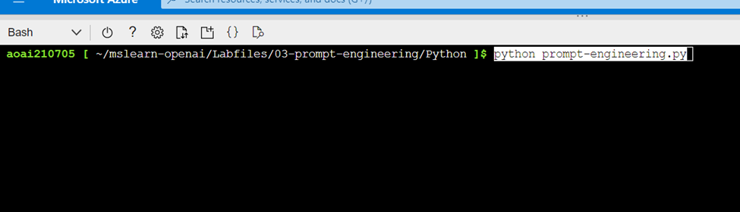
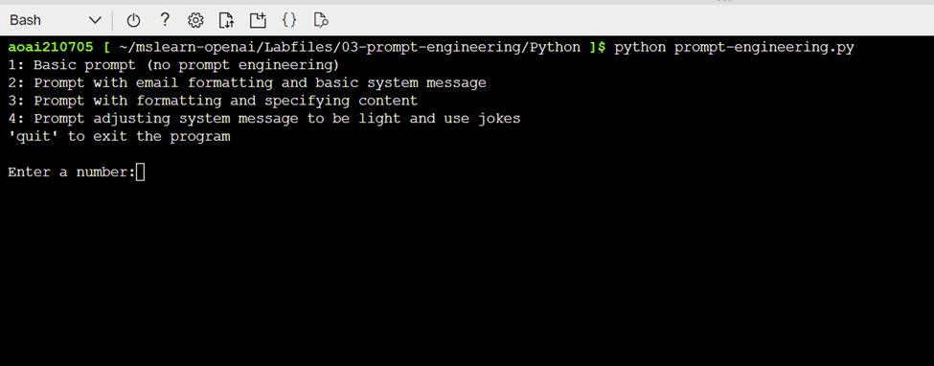
- Choose option 1 for the most basic prompt.
- Observe the prompt input, and generated output. The AI model will likely produce a good generic introduction to a wildlife rescue.
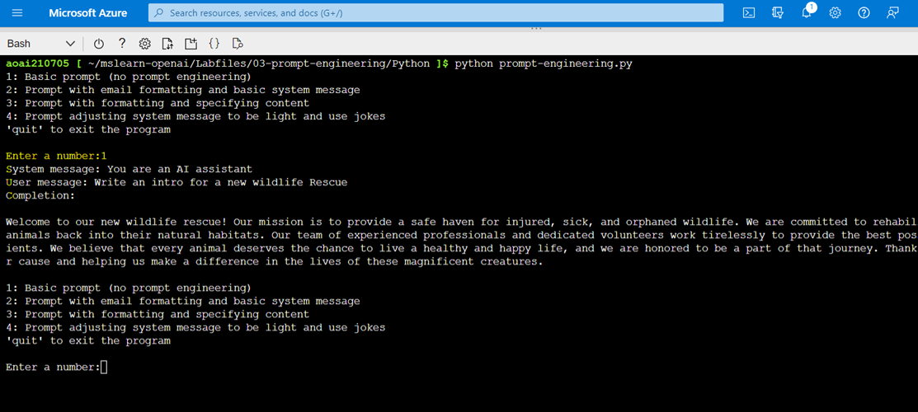
- Next, choose option 2 to send a prompt asking for an intro email, along with some details about the wildlife rescue.
- Observe the prompt input, and generated output. This time, you'll likely see the format of an email with the specific animals included, as well as the call for donations.
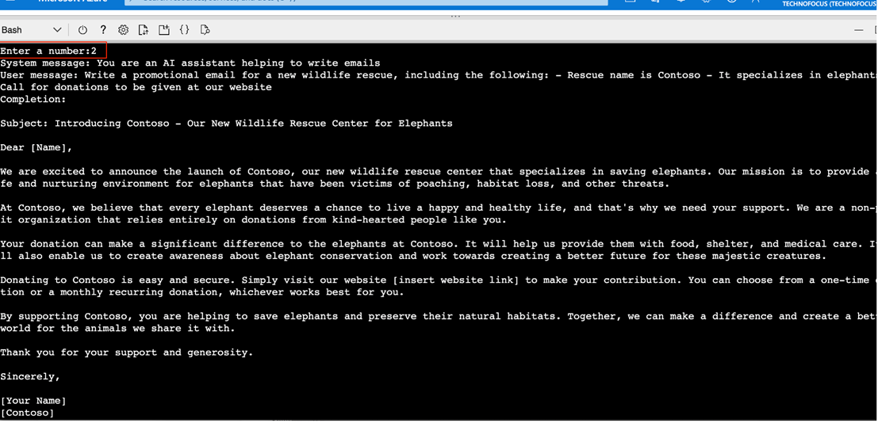
- Next, choose option 3 to ask for an email similar to above, but with a formatted table with additional animals included.
- Observe the prompt input, and generated output. This time, you'll likely see a similar email with text formatted in a specific way (in this case, a table near the end) demonstrating how the generative AI models can format output when requested.
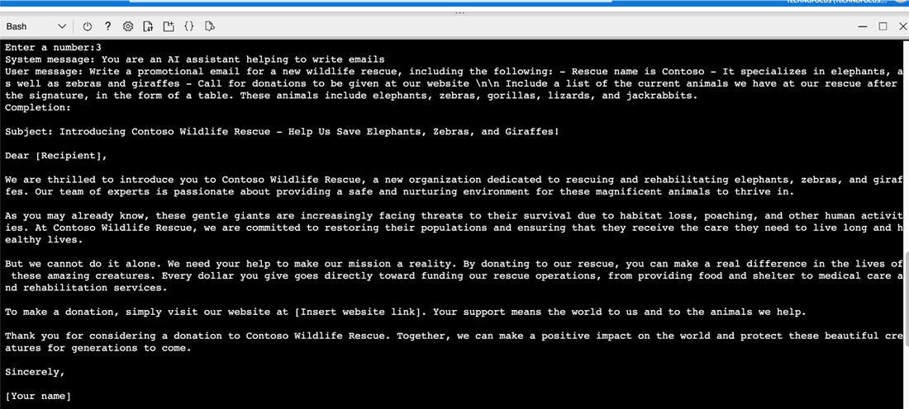
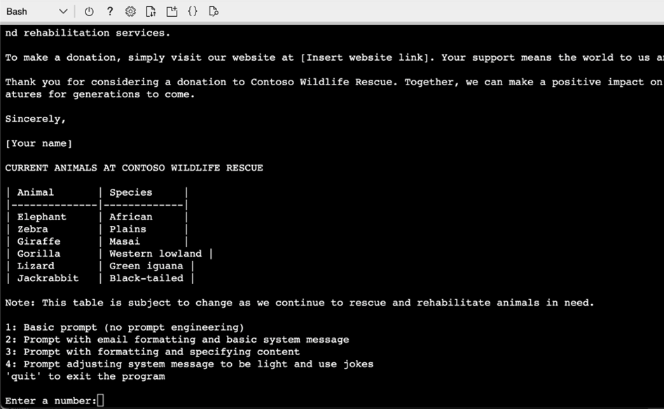
- Next, choose option 4 to ask for a similar email, but this time specifying different tone in the system message.
- Observe the prompt input, and generated output. This time you'll likely see the email in a similar format, but with a much less informal tone.
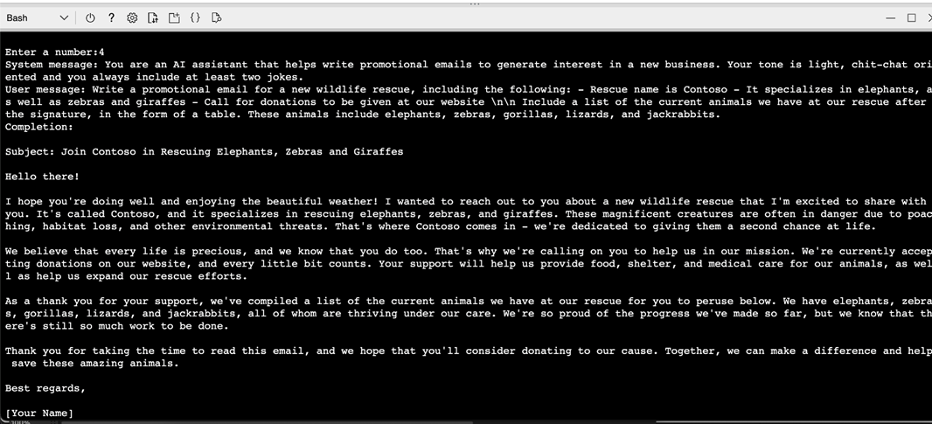
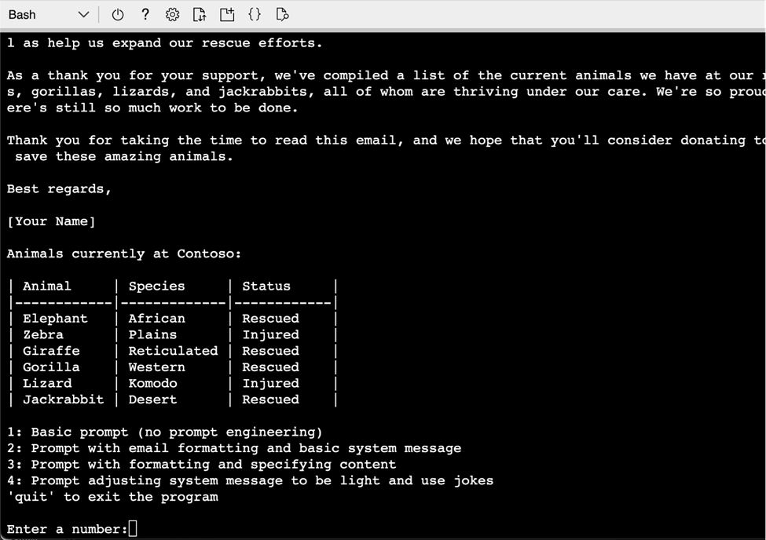
- Next, choose option quit to exit the program.
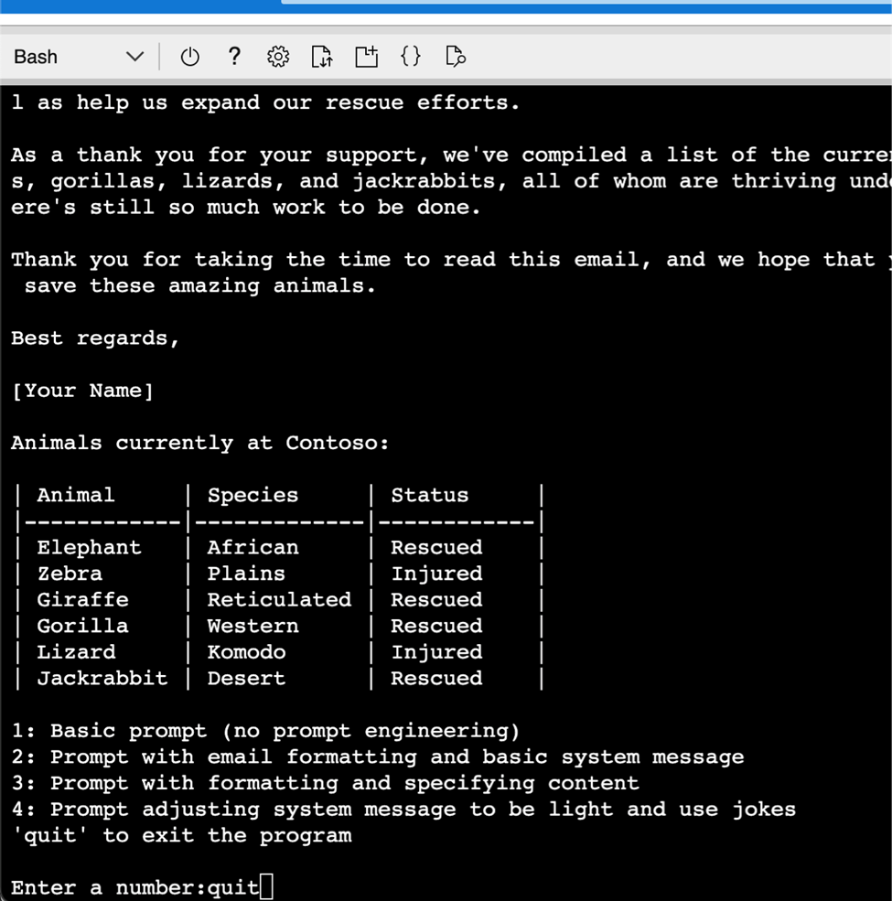
- Increasing the temperature often causes the response to vary, even when provided the same prompt, due to the increased randomness. You can run it multiple times with different temperature or top_p values to see how that impacts the response to the same prompt.
- Use the following command to open the lab files in the code editor.
code .
- Open PromptEngineering.py.To see the full response from Azure OpenAI, set the printFullResponse variable to True (Line #74) as shown in the image.
if printFullResponse:True
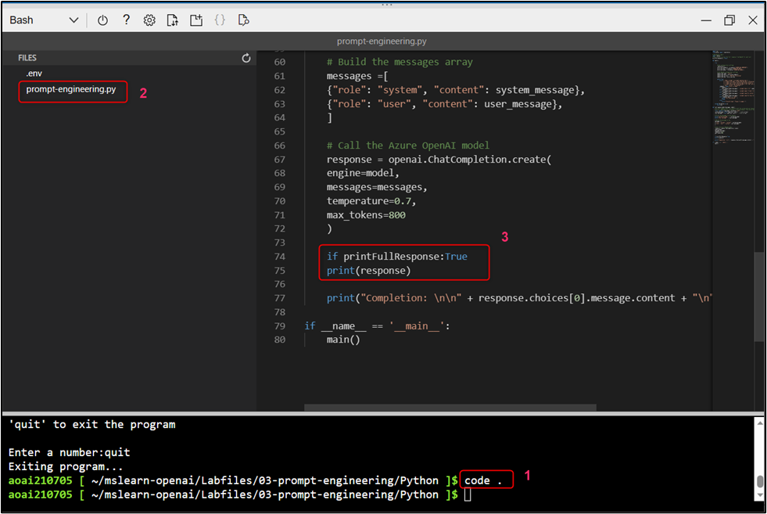
- Press Ctrl+S to save your changes. Then, press Ctrl+Q to quit the code.
- In the Cloud Shell bash terminal, run the application using the following command.
python prompt-engineering.py
- Choose option 1 for the most basic prompt.
- Observe the prompt input, and generated output. The AI model will likely produce a good code generic introduction to a wildlife rescue.
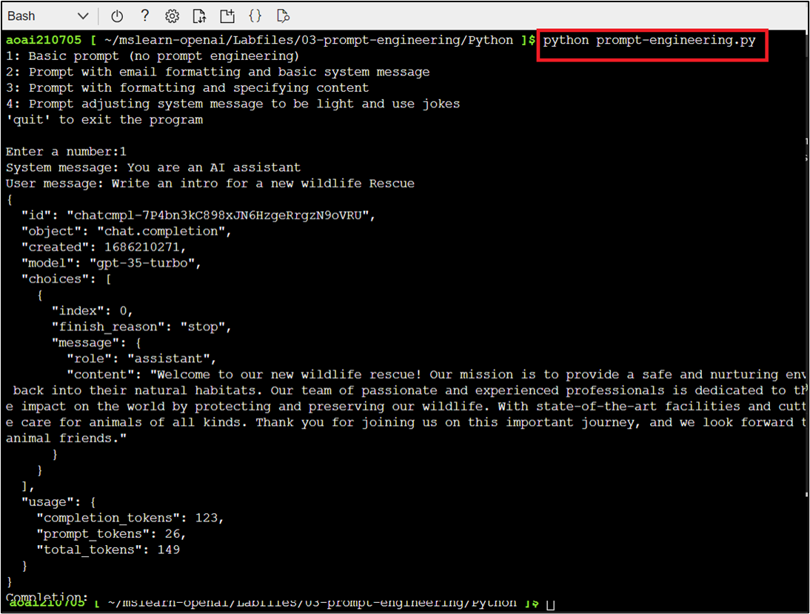
Note: (1). In case, you received an indentation error related to line #75, then remove the space before print(response) and adjust the position as shown in step #13 image.
(2). In case, you did not find code generic text, then close the Cloud Shell and open it again by clicking on the [>_] (Cloud Shell) button at the top of the page and enter the following commands:
- Next, choose option 2 to send a prompt asking for an intro email, along with some details about the wildlife rescue.
- Observe the prompt input, and generated output. This time, you will see the format of an email with code the specific animals included, as well as the call for donations.
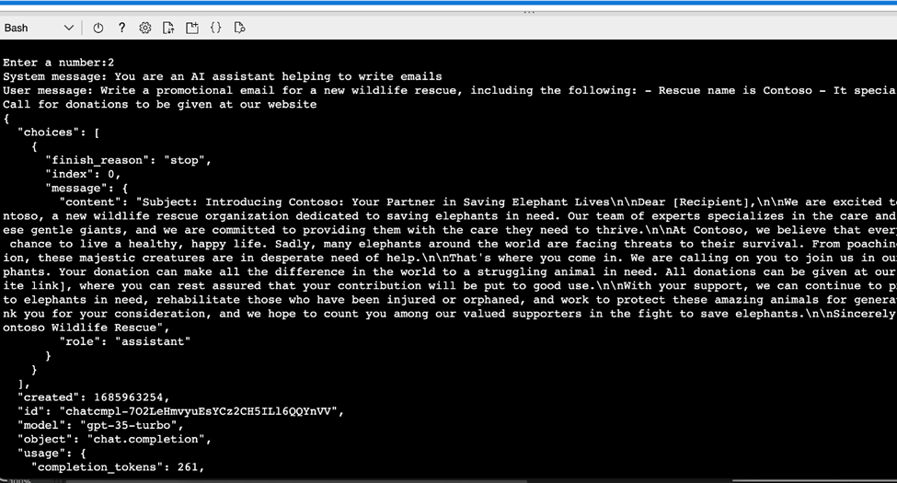
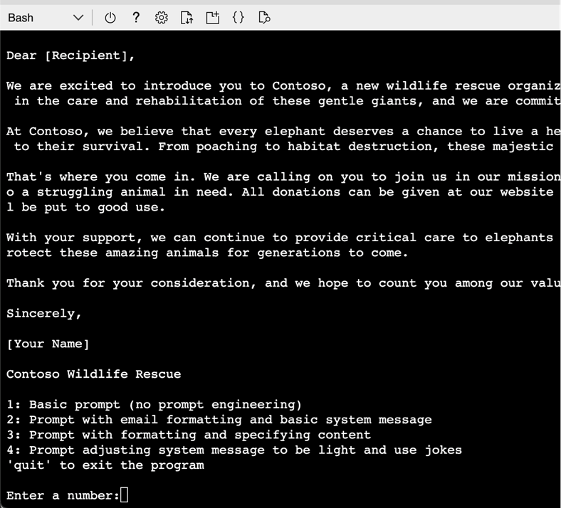
- Next, choose option 3, observe the prompt input, and generated output.
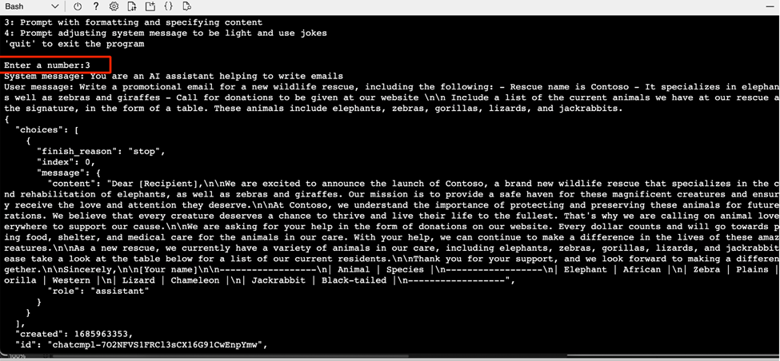
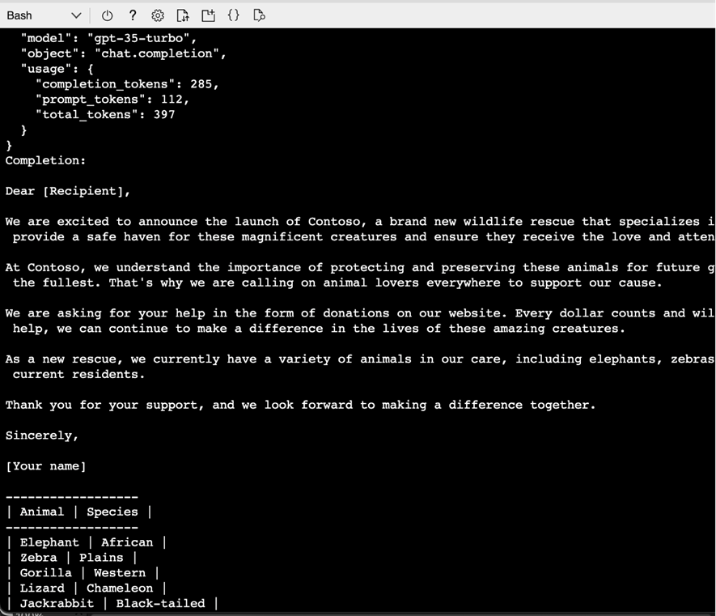
- Choose option 4, observe the prompt input, and generated output.
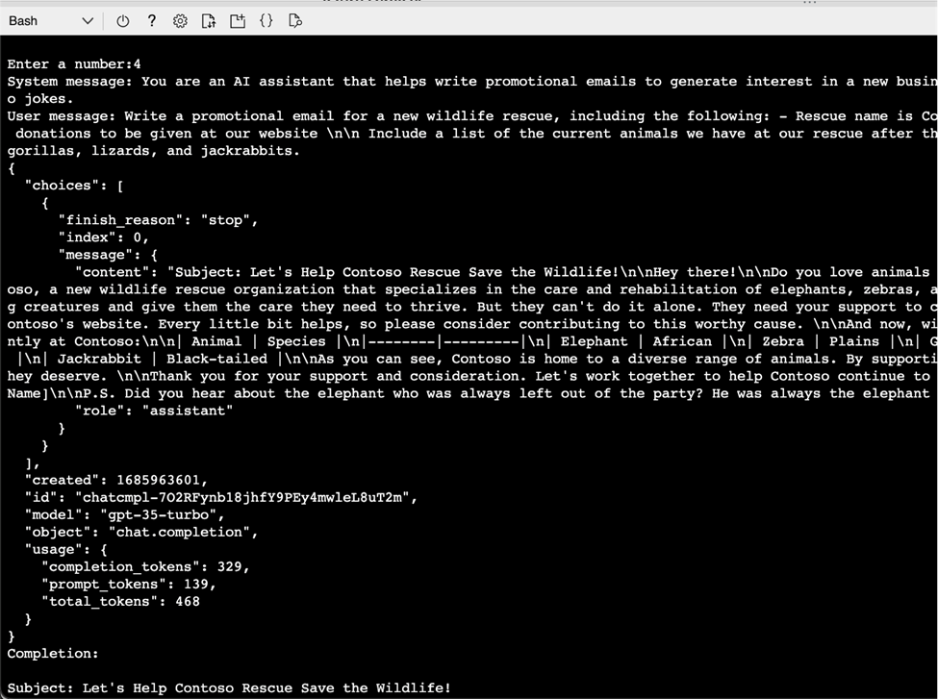
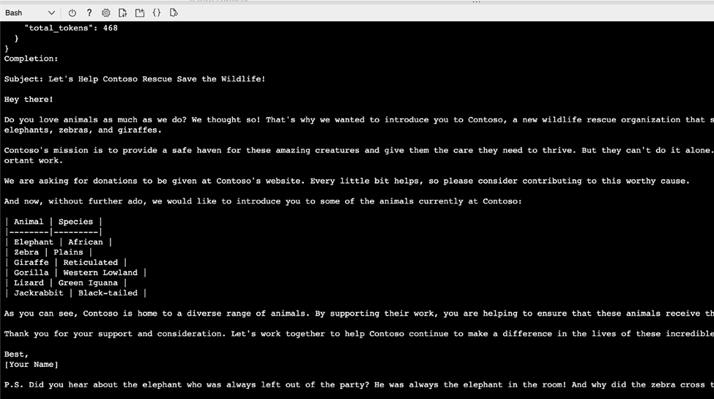
- Next, enter quit to exit the program.
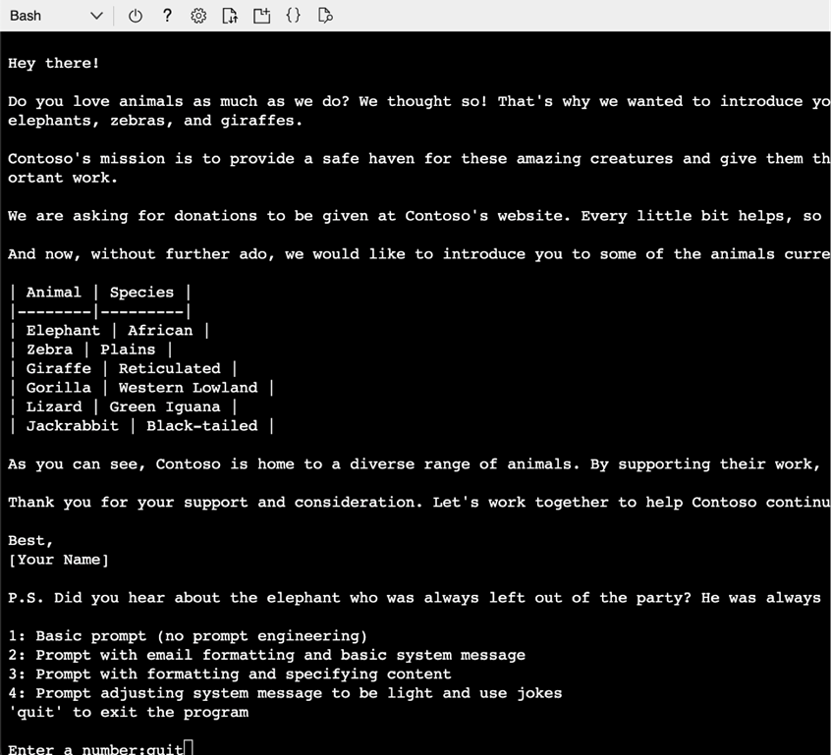

Task 6: Clean up resources
- In Azure OpenAI Studio, on the left pane, under the Management section, click on Deployments.
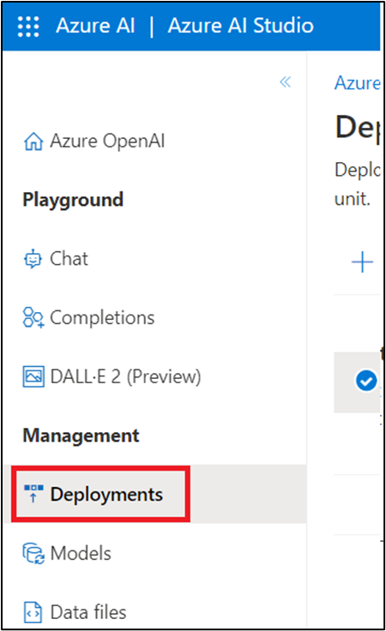
- Select text-turbo deployment name and click on Delete deployment.
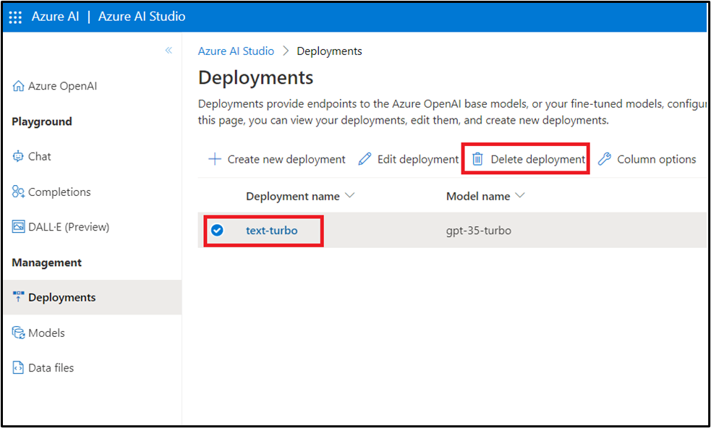
- In the Confirm delete dialog box, click on the Delete button. You will see the notification -- Successfully Deleted deployment (In case, you did not see the notification, then click on the bell icon beside Azure AI | Azure AI Studio).
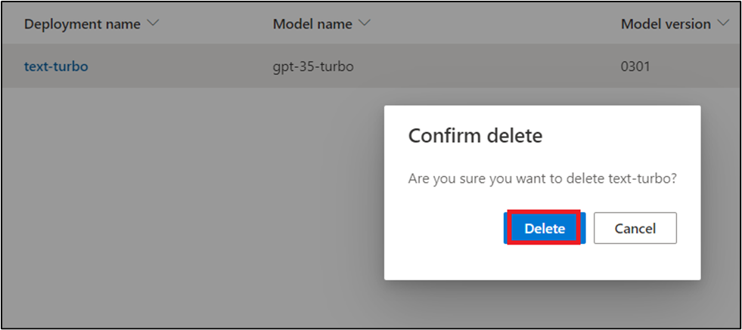
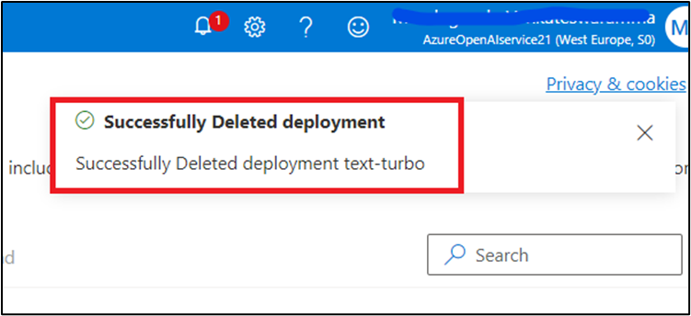
- From the Azure portal Home page, click on Resource groups.
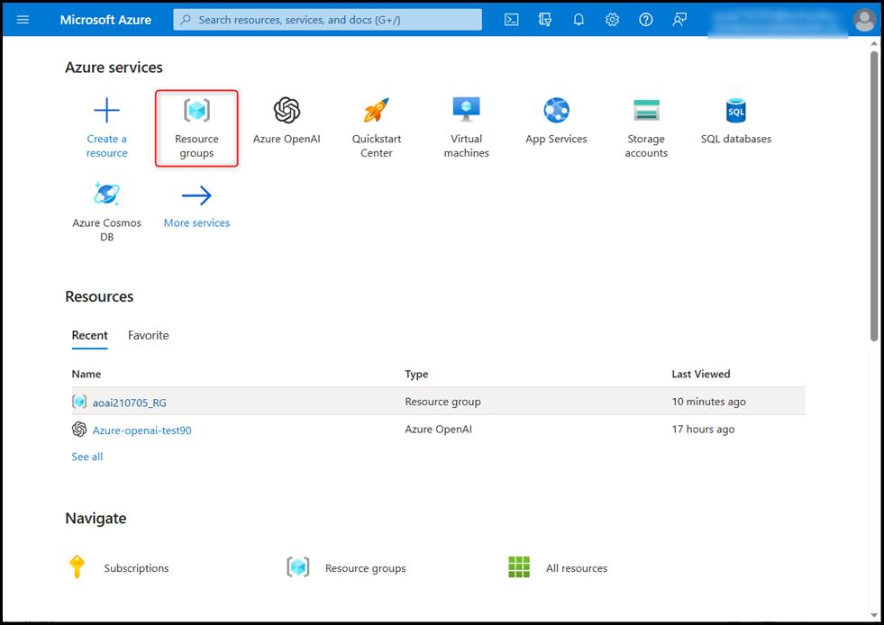
- Click on the resource group AzureOpenAIRG and click on Delete Resource group.
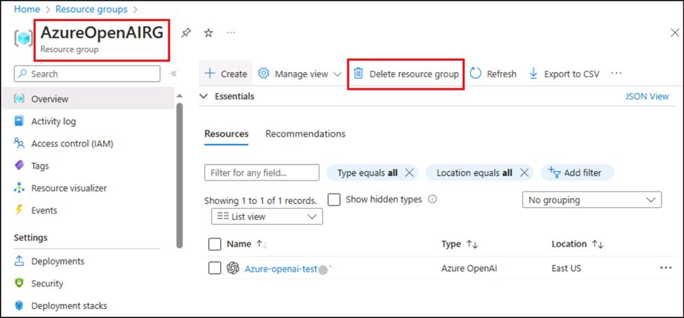
- Type in the Resource group and click on Delete.
- A success message is obtained once the Resource group is deleted.
Summary
In this lab, you've deployed gpt-turbo-35 model in Azure AI Studio, examined how prompt engineering improved the model response in the Chat playground. You've set up, configured, and ran your application in Azure Cloud Shell, then you've sent your request to the gpt-35-turbo model and observed the response. In the last task, you've deleted the deployed model and storage account to efficiently manage your Azure resource.

